**Database Group 5**

**The CRAM Reservation System**

*MANUAL*

Appalachian State University

Chris Herge, Jennifer Lindley, Nathan Hernandez, Sina T

Professor

**Step 1: Log In**

1. Getting to the CRAM Login Page
   1. Open a web browser on a Desktop or Laptop computer.
   2. 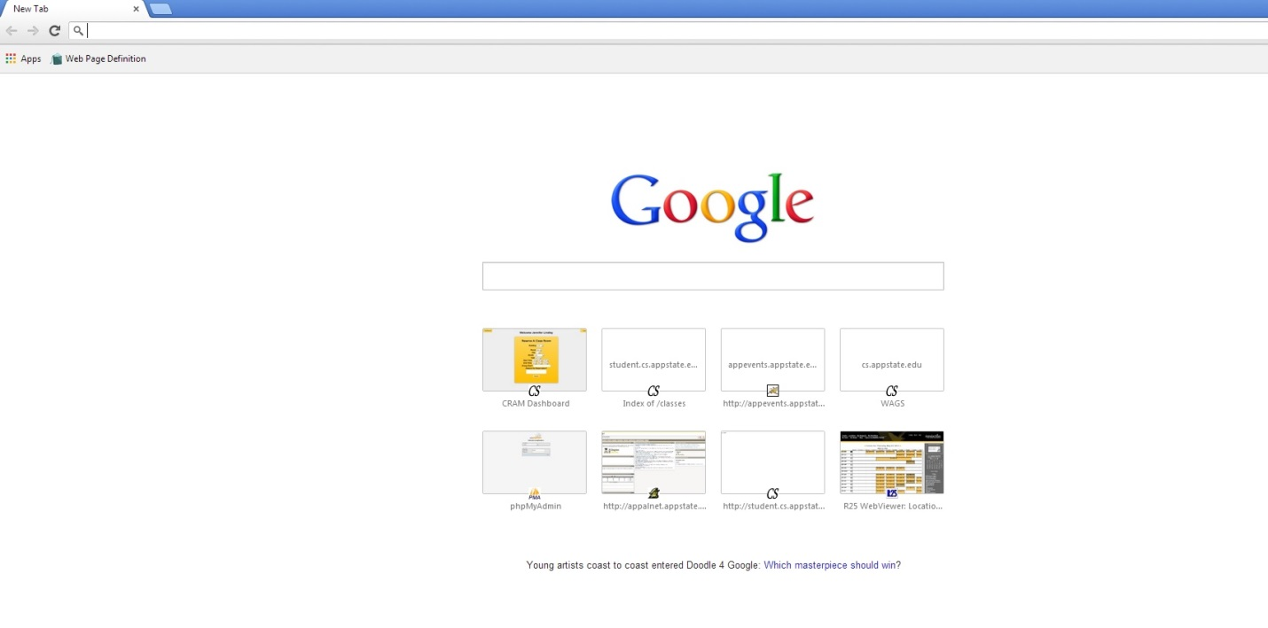In the address bar, **Figure 1,** type: student.cs.appstate.edu/3430/131/team5

**Figure 1**

Address Bar:

student.cs.appstate.edu/3430/131/team5

* 1. 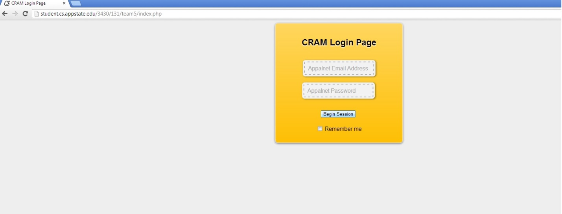Once you have typed the address from step 2 into the address bar and hit enter, **Figure 2**, the CRAM page should load.

**Figure 2**

1. Logging In
   1. 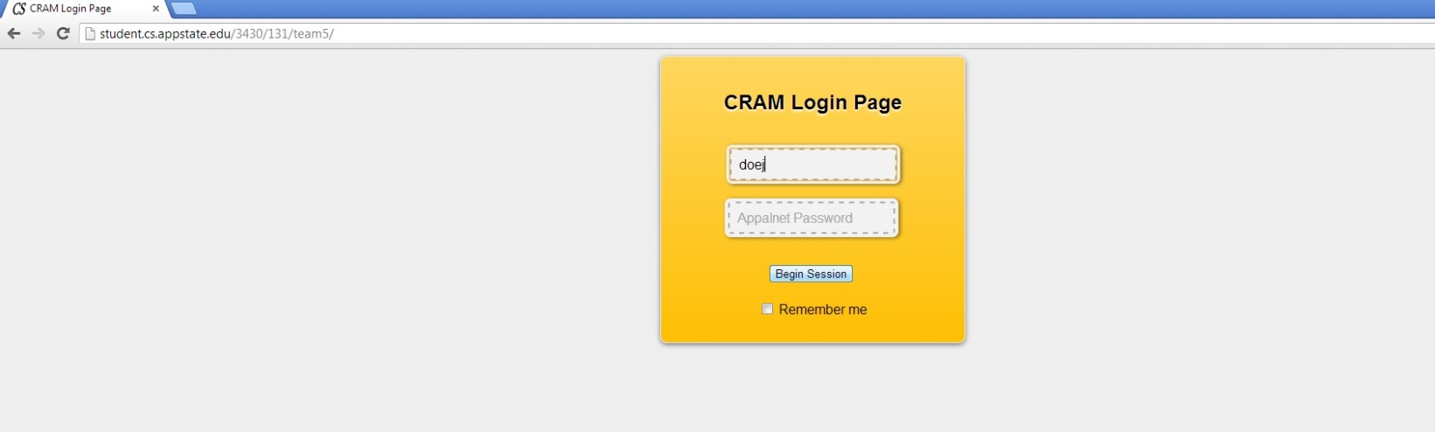In order to login into the CRAM site a valid Appalachian State user name should be entered into the first text box that reads: Appalnet Email Address. For example, **Figure 3**, a student named John Doe would enter in doej.

**Figure 3**

Student: John Doe

Student’s ASU email: [doej@appstate.edu](mailto:doej@appstate.edu)

CRAM login: doej

* 1. Next the Appalachian State University password associated with the username must be entered into the second box that reads: Appalnet Password. For example, **Figure 4** shows John Doe’s password being entered into the correct box.

**Figure 4**

Joe’s Password entered into the second text box

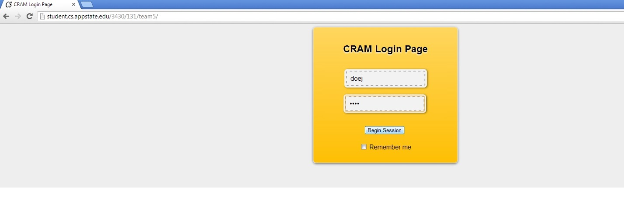

* 1. Once the user has typed in a correct username and password, the user has the option of checking the Remember me box below the Begin Session button so they do not have to log in again if they leave the site. After the Begin Session is clicked, the user will be taken to the Dash Board Page.
     1. If an incorrect username or password was entered, a pop up message box will notify the user that there was a log in error. **Figure 5** shows an example of an incorrect username/password combination.

**Figure5**

Pop up message notifying user that an incorrect username/password was entered.

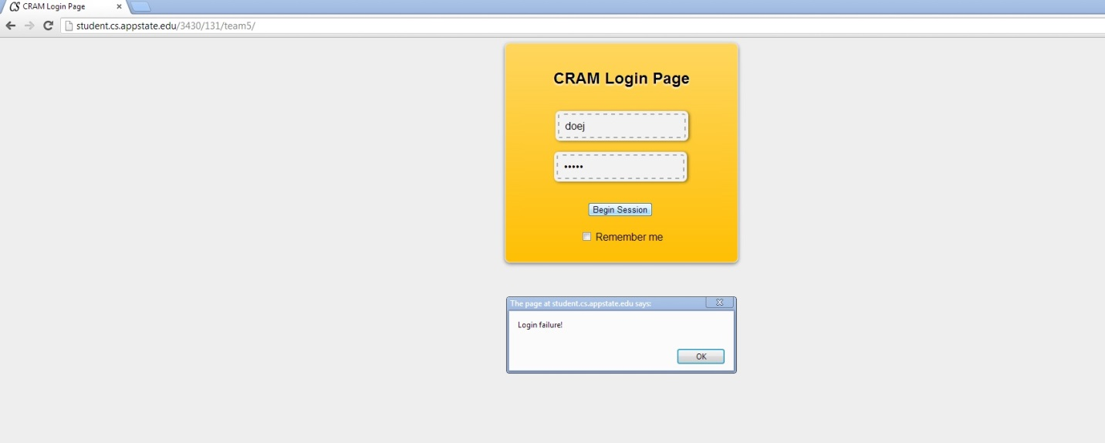

Step 2: Using the Dash Board

1. How to use the Dash Board
   1. User reservations as well as faculty other student reservations will be displayed on the Dash Board screen. **Figure 6**
   2. A user can reserve a room by clicking the Reserve a Room button, **Figure 7**, or log out of CRAM site by clicking the Logout buttong on the Dash Board. **Figure 8**

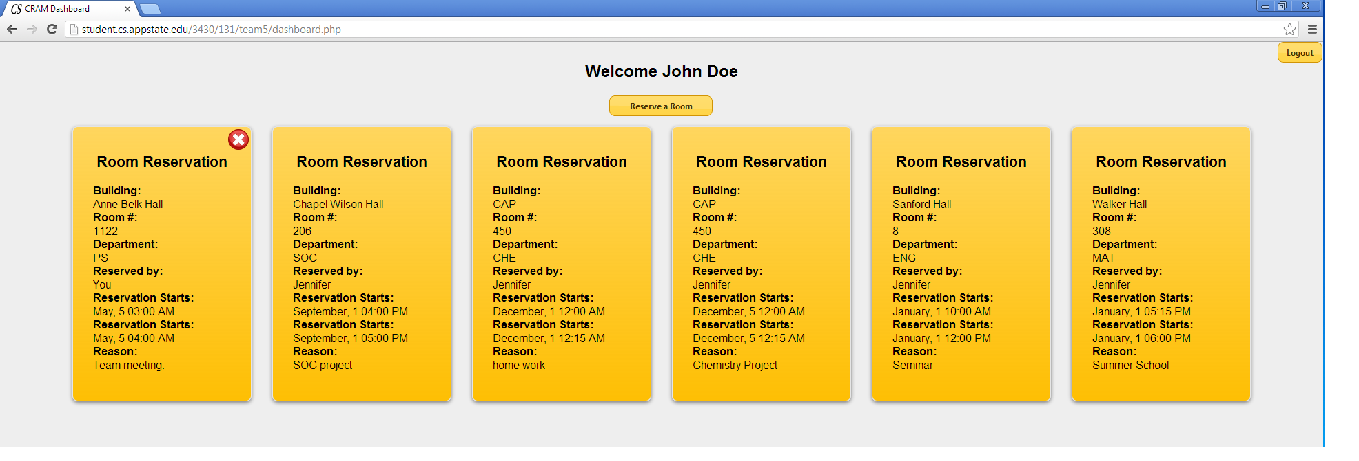

Click the Reserve a Room button to make a class room reservation

**Figure7**

Click the log out button to log out of CRAM

The name of the user that logged into CRAM

**Figure8**

**Figure6**

Reservations made by the user currently logged into CRAM

Reservations made by other students and faculty

**Figure6**

Hitting this Reserve a Room button will allow the user to reserve a room

**Figure7**

Log out button to log out of CRAM

Name of user that logged into the CRAM site

**Figure8**

1. How to make a reservation
   1. Once at the reserve page, the user will notice a Dash Board button on the top left side of the web page frame and a logout button on the top right side of the web page frame.
      1. If the user wishes to look at current reservations then the user should click the Dashboard button. **Figure 9**
      2. If the user wishes to log out of cram, then the user should hit the Logout button. **Figure 10**
   2. The first drop down menu is the building menu. This is where the user can select the building in which they wish to reserve a classroom in. **Figure 11**
   3. The second drop down menu is the room menu. The CRAM website displays which rooms are available to reserve in a specific building. **Figure 12**
   4. The date has three drop down menus that consist of the day of the month followed by the month, then the year that the the user wants to reserve the room. **Figure 13**
   5. The start time has three drop down menus that consist of the hour of the reservation followed minutes then the option of AM or PM. **Figure 14**
      1. AM represents times from 12:00 AM to 11:59 AM.
      2. PM represents times from 12:00 PM to 11:59 AM.
   6. The end time has three drop down menus that consist of the hour of the reservation followed minutes then the option of AM or PM. AM represents times from 12:00 AM to 11:59 AM. PM represents times from 12:00 PM to 11:59 AM. **Figure 15**
      1. The end time must be later than the start time.
   7. The user must enter the number of total participants that are going to be in the room at the particular time. **Figure 16**
      1. If the user forgets to enter a group size then the group size defaults to one.
   8. Lastly, the user must enter a reason that they want to reserve a room. **Figure 17**

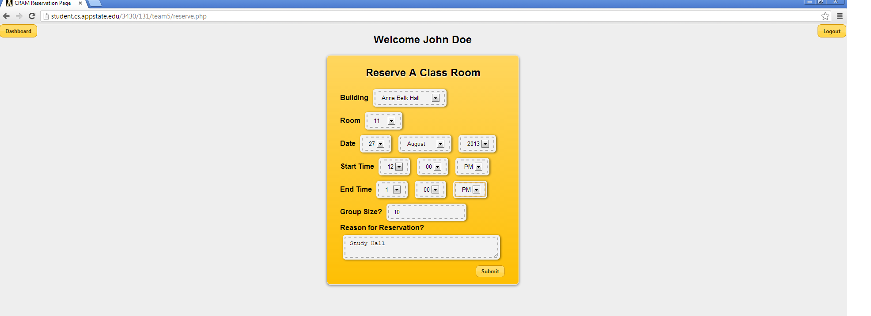

**Figure11**

Click the down arrow to see more room number options.

**Figure11**

Click the down arrow to see more building options.

**Figure9**

Click the Dashboard button to go back to see current reservations.

**Figure10**

Click the log out button to log out of CRAM.